Yr11 Physics 

Topic Test : Nuclear Physics : 48 marks

Name: Class: Date: __________

Question 1 ( 1 mark)

Which of the following travels at the greatest speed?

A gamma radiation

B beta radiation

C alpha radiation

D they all travel at the same speed

Question 2 (1 mark)

Which of the following best describes beta-minus radiation?

A energy emitted from an electron of an atom

B an electron ejected from an atom

C a helium nucleus emitted from an atom

D an electron emitted from the nucleus of an atom

Question 3 ( 1 mark)

Which of the following options is the most penetrating form of radiation?

A gamma

B beta

C alpha

D none of the above

Question 4

For two nuclei to undergo fusion, which of the following must be overcome? (1 mark)

A strong nuclear force

B electrostatic force

C binding force

D weak nuclear force

**Question 5**

Which of the following is responsible for holding the nucleus of an atom together? (1 mark)

A strong nuclear force

B weak nuclear force

C binding force

D electrostatic force

E gravity

Question 6

For the following radioisotope, calculate the number of:

**i** protons; **ii** neutrons; **iii** nucleons.

 (3 marks)

Question 7

1. Strontium-90 is one of the radioisotopes that were released during the Fukushima nuclear disaster in Japan. Strontium-90 has a half-life of 28.8 years.

If 1.8 × 1010 atoms of strontium-90 were released during the accident, calculate how many of the original strontium-90 nuclides will still be in existence in 144 years? (2 marks)

1. A radioactive sample of oxygen-15 has a half-life of 110 minutes. If the amount of oxygen-15 remaining after 5.5 hours is 0.80 g, calculate the mass of the original sample. (3 marks)

**(c)**  A scientist uses a Geiger counter to measure the radiation of a radioactive sample. She records the count as 90 000 emissions per minute.

Calculate the activity of the sample in becquerel (Bq). (1 mark)

Question 8

a Rank the following forms of radiation from least ionising to most ionising: (1 mark)

beta, alpha, gamma.

b Explain your answer to part a. (2 marks)

Question 9

In the following decay equations determine the unknown, *X*?

**a**  (1 mark)

**b**  (1 mark)

Question 10

When bombarded with neutrons, gold (Au-197) undergoes neutron absorption to become the radioactive isotope gold-198. Given that gold has an atomic number of 79, write a balanced equation for the following:

**a** the absorption of a neutron by a gold-197 atom (2 marks)

**b** the beta decay of a radioactive nucleus of gold-198. (2 marks)

Question 11

An 85 kg man is exposed to 250 mJ of gamma radiation. Calculate:

**a** his absorbed dose (1 mark)

**b** his dose equivalent (1 mark)

**c** his dose equivalent if he had been exposed to 250 mJ of alpha radiation instead (1 mark)

**d** the energy of the radiation he is exposed to in electronvolts (eV). (1 mark)

Question 12

The radioactive decay of a particular isotope is shown on the graph below. The initial mass of the radioisotope is 40 g. Use the graph to help answer the following questions.

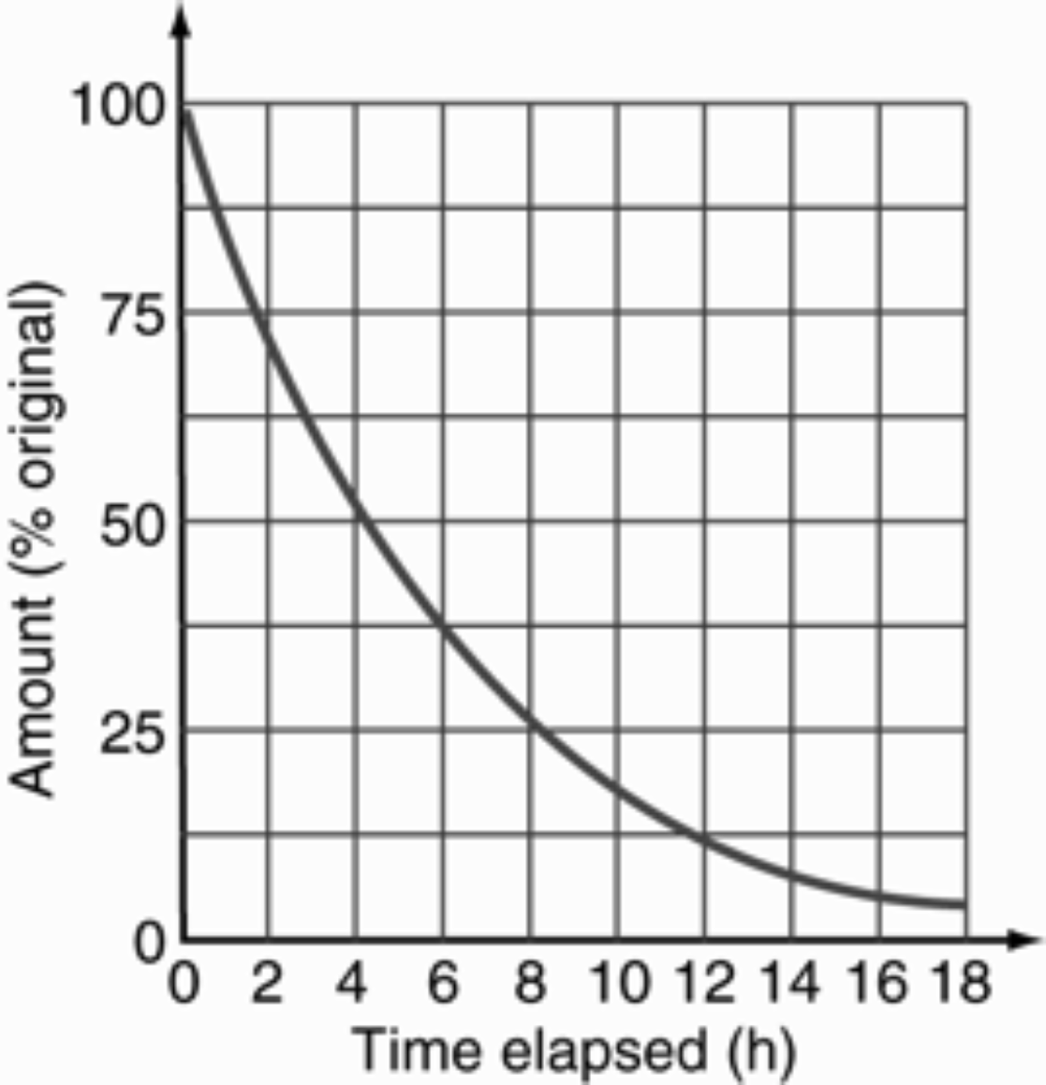

**a** Find the time it takes for a 40 g sample to decay to 10 g. (2 marks)

**b** Find the half-life of the sample. (1 marks)

**c** **From the graph**, find how much of the original radioisotope (in grams) remains after 10.0 hours.

(2 marks)

Question 13

aA scientist is using a Geiger counter to examine a locked box made of very thin aluminium. The Geiger counter detects some radiation being emitted through the top of the box. Without opening the box, the scientist puts a thick sheet of aluminium around the box and finds that the activity registered by the Geiger counter reduces. What type(s) of radiation could be present? (Assume neutrons are not present.) (2 marks)

b The scientist then puts a strong magnetic field across the box. She finds that the direction of the radiation changes and there is no radiation in the original direction. What type of radiation is it, and why? (2 marks)

Question 14

Consider the following fission reaction:



a Convert the energy released into joules. (1 mark)

b For each nuclei of uranium-235 calculate how much mass (in kg) was converted to energy in the reaction? (2 marks)

d Using the fact that 1.00 kg of uranium-235 contains 2.5 × 1024 nuclei, how much energy would be released if all the nuclei in 1.00 kg of uranium-235 underwent fission? (2 marks)

Question 15

One of the reactions that takes place in a fusion reactor is shown below:



a How many neutrons are released during this reaction (i.e. what is the value of )? (1 mark)

b How does the combined mass of the reactants compare with the combined mass of the products in this fusion reaction? (No calculation required) (2 marks)

**c** What happens to this difference in mass? (1 mark)

d One of the fusion reactions taking place inside the Sun is shown below:



Identify the missing nuclide, *X*. (2 marks)